INTRODUCTION
Over the past two years, the University has experienced an increase in students admitted to The Bridge with BACs (Blood Alcohol Content) exceeding .20 and placed in protective custody for up to 24 hours. In 2016, thirty-one students were transported to local hospitals for acute alcohol intoxication – an increase of 45% over the previous year. Neighborhoods adjacent to the campus report an increase in wild parties that disrupt their quality of life and leave their properties littered with trash and/or vandalized. Many of these problems make their way back to campus creating challenges for University Housing staff, Greek house directors and campus law enforcement. Unfortunately, a significant percentage of these problems are associated with social events hosted by members of Nebraska’s Greek community.
In response to the growing problem, Juan Franco, University of Nebraska-Lincoln Vice Chancellor for Student Affairs, commissioned a Campus-Community Task Force charged with addressing negative behaviors associated with high-risk alcohol consumption. The Task Force is expected to develop and present a comprehensive strategic response to senior administrators by the end of the 2017 spring academic semester. The purpose of this Briefing Report is to provide Task Force members with the background information necessary to begin that process.
OVERVIEW
In 1998, the American Medical Association awarded the University one of ten “A Matter of Degree” grants funded by the Robert Wood Johnson Foundation to create a campus-community coalition, NU Directions, which would utilize environmental strategies to reduce high-risk drinking among Nebraska students. A comprehensive strategic plan of 13 goals and 60 objectives sought change through community and campus-based policies and enforcement programs, responsible hospitality practices in the retail environment, targeted programs in the neighborhoods surrounding the campus, motivational and normative feedback programs, and social norms campaigns to support culture change (Newman et al., 2006).
Data collected through the 1997 Harvard School of Public Health College Alcohol Study (CAS) indicated that the University’s binge drinking rate was significantly higher than the national average (62% compared to the national average of 44%). Identified contributors to this high drinking rate included the existence of a high-profile athletics program, a large and active residential Greek system, a high density of alcohol outlets within one mile of the campus and inconsistent enforcement of alcohol-related laws and policies on campus and in the community. CAS data also indicated a high rate of drinking among incoming first-year students, which was consistent with Youth Risk Behavior Survey data (2001) showing that Nebraska high school students had one of the highest per capita drinking rates in the country.
Consistent with national findings, Greek-affiliated students had drinking rates that were significantly higher than their non-Greek peers (Wechsler et al., 2008). At the time, the Greek “binge” drinking rate was 76% compared to a 62% rate among the general student population. Though Greek-affiliated students constituted only 16% of the undergraduate population, those students comprised a disproportionate number of high-risk drinkers on campus.
CHANGES IN DRINKING BEHAVIORS
Figure 1 shows the overall binge-drinking rate (five of more drinks for men and four or more drinks for women) per drinking session across all survey years. The percentage of Nebraska students who binged on at least one occasion in the past 2 weeks dropped from 62% in 1997 to 38% in 2015. This 24% change was statistically significant and places Nebraska student drinking rates at or below the current national average. Of those students who reported binge drinking in the 2015 survey, 25% reported binge drinking 1-2 times and 12% reported binge drinking 3 or more times in a two-week period.
In addition to binge and other high-risk drinking, the coalition placed considerable emphasis on reducing harms associated with drinking. There was a statistically significant decrease in the alcohol-related problems experienced by students including missing a class, getting behind in work or school, memory loss, regret, unplanned sexual activity, injury and/or physical assault.

Figure 1. University of Nebraska-Lincoln Student Binge Rate 1993 – 2015
While the overall student binge rate declined steadily over the last 20 years, the campus has yet to realize similar gains among the Nebraska Greek community. As shown in Figure 2, data collected as part of the 2015 Bystander Intervention Survey, suggests that University fraternity and sorority binge rates, 63% and 62% respectively, are significantly higher than other student groups on the UNL campus and well above the campus binge rate of 38%. Faith-based groups (31%), recognized student organizations (37%), and sport clubs (37%) report binge rates that are at or below the campus average of 38%. Intramural sport clubs, many of which are populated with Greek members, report a binge rate of 44%. Although the number of Greek respondents was relatively low (N=199), the Bystander Survey provides a first glance at the difference between a Greek and non-Greek student groups active on the University campus.

Figure 2. Five or More Drinks by Group Affiliation
FIRST-YEAR DRINKING PATTERNS
In 2002, the campus experienced a shift from a majority of infrequent and frequent binge drinkers to a significant percentage of incoming students who report either abstaining from alcohol or drinking in low risk ways when they do choose to consume alcohol (Figure 3). Entering class data is collected, pre-arrival, through the administration of the Year 1 College Alcohol Profile (Y1-CAP) to entering first year students. Y1-CAP is an alcohol prevention program developed at the University of Nebraska-Lincoln and modeled on national web-based brief intervention programs such as e-CHUG.
The Y1-CAP provides personalized feedback to students based on input of their own drinking and self-reports of harms. The student’s drinking patterns are compared to peer reference norms. Additional information is provided on alcohol effects, BAC, local policies and laws, and social norms message providing students with peer group drinking and attitudinal norms to correct drinking misperceptions. Despite campus efforts to correct misperceptions about peer alcohol and other drug use, Nebraska students over estimate any use of alcohol within the last month by 30% and marijuana use within the last 30 days by 64% (Fall 2016 ACHA-NCHA II Survey – University of Nebraska-Lincoln Executive Summary). Correct drinking norms are an important prevention strategy as research suggests that students may adjust their behavior to fit in with what they believe to be the normative campus environment.

Figure 3. University of Nebraska-Lincoln Drinking Classification by Entering Class 1997 – 2015
Detailed information about the drinking patterns of the entering class beginning with 2009 is displayed in Figure 4. Overall, more than 40% of entering students coming to UNL report that they abstain from consuming alcohol. In 2016, slightly more men (44.4%) than women (43.1%) reported abstinence. Overall 20.2% of the first-year student respondents reported binge drinking, with more men (22.4%) than women (18.4%) reporting the behavior. This compares to 27.4% of Nebraska high school seniors who reported binge drinking on the 2015 Youth Risk Behavior Survey.
Members of the entering class who self-report an interest in Greek membership report drinking rates that exceed their non-Greek peers. In 2016, 27.2% Greek respondents reported abstaining from alcohol as opposed to the 49.2% rate reported by their non-Greek peers. Their binge rates are also higher. In 2016, the binge rate of students interested in joining the Greek system exceeded 31% - nearly double (15.7%) of their non-Greek peers. This pattern is consistent across the three reporting years (2014-2016) reflected in Figure 4.

University of Nebraska-Lincoln
2009 – 2016 Entering Class Comparison Report and 2014 – 2016 Entering Greek vs Non-Greek Comparison Report
 | Abstainer | Drink no Binge | Infrequent Binger | Frequent Binger
2016 Respondents (3690) | 43.4% | 37.2% | 8.9% | 10.4%
2016 NCC* Respondents (7943) | 51.3 | 34.3 | 6.7 | 7.8
2015 Respondents (3941) | 40.8% | 40.2% | 7.8% | 11.2%
2014 Respondents (3453) | 43.7% | 36.1% | 8.2% | 12.0%
2013 Respondents (2989) | 45% | 34.2% | 8.7% | 12.1%
2012 Respondents (2620) | 49.7% | 30.4% | 7.7% | 12.1%
2011 Respondents (2924) | 45.9% | 31.7% | 8.8% | 13.6%
2010 Respondents (2279) | 43.9% | 33.7% | 9.6% | 12.8%
2009 Respondents (3042) | 42.3% | 31.7% | 21.0% | 5.0%
2014 – 2016 FY CAP Comparison (UNL Greek vs UNL Non Greek)
2016 Greek Respondents (889) | 27.2% | 41.8% | 12.9% | 18.1%
2016 NCC* Respondents (1798) | 34.7% | 42% | 9.4% | 13.9%
2016 Non-Greek Respondents | 49.2% | 35.2% | 7.8% | 7.9%
2015 Greek Respondents | 25.6% | 44.5% | 10.4% | 11.2%
2015 Non-Greek Respondents | 49% | 37.9% | 6.4% | 6.8%
2014 Greek Respondents | 29.2% | 37.9% | 12.7% | 20.1%
2014 Non-Greek Respondents | 52.9% | 34.9% | 5.3% | 6.9%
Figure 4. UNL First-Year College Alcohol Profile (Y1-CAP)
*The Nebraska Collegiate Consortium (NCC) is a coalition of 28 Nebraska post-secondary institutions working together to reduce high-risk drinking among college students. Eleven of the 28 participating institutions administered the Y1-CAP in prior to the 2016-2017 academic year.

EXTREME DRINKING
Research suggests that drinking beyond the standard 5/4 measure is more common among young adults ages 19-24, including college students. In a 2010 study, Naimi and colleagues found that young adults, similar in age to the traditional undergraduate population, consumed alcohol at levels twice the gender-neutral 5 drink level or on average 9.5 drinks per drinking occasion. While national trends suggest that binge drinking among young adults has declined, many report an increase in what is often termed as extreme drinking or high intensity drinking which might help explain the increase in alcohol-related hospitalizations, emergency room visits and deaths (White, 2017).
Student admissions to Civil Protective Custody at The Bridge Behavioral Health increased by 41% from academic year 2013-2014 to 2015-2016. Civil Protective Custody is a medically supervised option for law enforcement officials concerned about someone who is a danger to themselves or others. Grounded in state law, clients admitted to the program may stay up to 24 hours or until released to a responsible friend or family member.
As displayed in Figure 5., the typical student admission to civil protective custody is more likely to be a white male, 20 years of age with an average BAC of approximately .20. Chances are he was drinking at home or at the home of a friend. It is important to note that 48% of the students admitted during the 2015-2016 academic year had a BAC at or above .20. Blackouts are possible at BACs of .20 and are linked to a variety of negative consequences including acute alcohol intoxication, sexual assault, and higher rates of violence. Research suggests that young men, and male freshmen in particular, are at higher risk for experimentation (Gruenewald et al., 2002).
Figure 5. University of Nebraska-Lincoln Student Admissions to The Bridge
Figure 5. University of Nebraska-Lincoln Student Admissions to The Bridge
Bridge
Figure 5. University of Nebraska-Lincoln Student Admissions to The Bridge

 | 2013-2014 | 2014-2015 | 2015-2016
Total Admissions | 141 | 199 | 238
Males | Male – 111  Female – 30 | Males – 148  Female – 51 | Male – 162  Female – 76
Race/Ethnicity | White – 111  Non-White – 30 | White – 179  Non-White – 20 | White – 214  Non-White – 24
Average BAC | .192  Above .20 – 80 (.237)  Above .30 – 5 (.339) | .20  Above .20 – 93 (.249)  Above .30 – 11 (.321) | .20  Above .20 – 116 (.235)  Above .30 – 15 (.322)
Average Age | 21 | 21 | 20.6
Social Host | Admissions – 96  Average BAC – .194  Average Age – 20 | Admissions – 142  Average BAC – .195  Average Age – 20.2 | Admissions – 181  Average BAC – .197  Average Age – 20.1
Commercial Host | Admissions – 45  Average BAC – .191  Average Age – 22 | Admissions – 67  Average BAC – .214  Average Age – 23.4 | Admissions – 57  Average BAC – .206  Average Age – 22.2
Extreme drinking is more likely to occur with special events and celebrations including a 21st birthday celebration, Halloween, St. Patrick’s Day or spring break. At Nebraska, students are more likely to engage in high-risk drinking in conjunction with a home football game. Figure 6 documents a steady increase in the number of students admitted to The Bridge for medically supervised detoxification services across three fall semesters beginning with the 2014-2015 academic year. Equally concerning is the steady rise in admissions with BACs in excess of .20.
In a 2010 study, Glassman and colleagues found that approximately 40% of the student study population participated in heavy game day drinking. Consistent with existing gender research, males typically consumed more alcohol than females. Greeks were twice as likely to engage in heavy episodic drinking in conjunction with game day activities. Nearly 50% of the Greeks surveyed reported engaging in extreme drinking as opposed to 1/3 of non-Greeks who reported similar drinking behavior.

Figure 6. Civil Protective Custody Admissions to The Bridge – Fall 2014, Fall 2015 and Fall 2016
ALCOHOL-RELATED VIOLATIONS
The University is able to track alcohol-related violations thanks to a cooperative agreement with the Lincoln Police Department. Each week, a list of alcohol-related citations issued in Lancaster County is pushed to the Office of the Vice Chancellor for Student Affairs regardless of citing agency e.g., LPD, UNLPD, Lancaster County Sheriff’s Office, and Nebraska State Patrol. Staff culls through the data to identify students cited for one of six citations typically associated with alcohol-related crime. Infractions include minor in possession/consumption (MIPC), DUI, disorderly house, procuring for minors, misrepresenting age, and underage attempt to purchase alcohol. The overwhelming majority of citations issued to students are for underage drinking (78.5%). Figure 7 provides a four-year comparison of the most common alcohol-related citations issued in Lancaster County.

Figure 7. Student Alcohol-Related Violations, Fall 2013 – February 2017
Across the four academic years, the University of Nebraska-Lincoln Police Department issued slightly more than one-half of the citations to students followed closely by the Lincoln Police Department (see Figure 8 below). A history of alcohol-related violations can derail even the best student’s future career plans. Risk adverse school systems avoid hiring prospective teachers with a history of alcohol-related problems and professional schools scrutinize applications from medical and law school applicants arrested for multiple infractions.
Alcohol-Related Citations Issued to Students by Law Enforcement Agency
Academic years 2013-2014, 2014-2015, 2015-2016, and 2016-2017
 | 2013-2014 | 2014-2015 | 2015-2016 | 2016-2017
Lincoln Police Department | 43% | 34% | 42% | 40%
Lancaster County Sheriff | 2% | 1% | 4% | 4%
UNL Police Department | 55% | 65% | 54% | 56%
Figure 8. Alcohol-Related Citations Issued to Students by Law Enforcement Agency

Beginning with the 2016-2017 academic year, the Office of Fraternity and Sorority Life agreed to begin tracking alcohol-related citations to members of the University Greek community. Of the 385 citations issued to students during the first full five months of the current academic year (September through January), 147 or 38% of the citations were identified as Greek members. Currently, 24.8% of the undergraduate student population is affiliated with a Greek chapter.
A point of pride from the NU Directions project was the dramatic decline in wild party complaints and repeat offenders. As presented in Figure 9, efforts to increase quality of life in the neighborhoods surrounding the University campus resulted in a 78% decline in wild party complaints citywide and a 62% decline in repeat complaints at the same address. Unfortunately, during the 2016 calendar year, area neighborhoods experienced an uptick in house parties resulting in a 12% increase over 2015. A slightly higher increase was observed in repeat complaints at the same address.

Figure 9. Wild Party Calls by Dispatch and Repeat Complaints, 2005 – 2016
Many of the wild party complaints reported during 2016 were affiliated with game day tailgates hosted in the backyard of one or more of the residential properties located in the North Bottoms. The citation numbers are deceiving. Given the demand for law enforcement resources on game day, many of the problems are handled on the scene by the officers without an arrest. Return visits to the same property are more likely to result in disorderly house citations issued to tenants and law enforcement contact with the landlord. Approximately 50% of the post event investigations identified Greek community involvement. Students cited for disorderly house are held responsible under the Student Code of Conduct for behavior disruptive to the community. Earlier this semester (Spring 2017), the Office of Student Conduct increased the consequences in an effort to curb growing neighborhood disruption of quality of life. On occasion, responding law enforcement officers provide photographs of the most disruptive gatherings including those below.
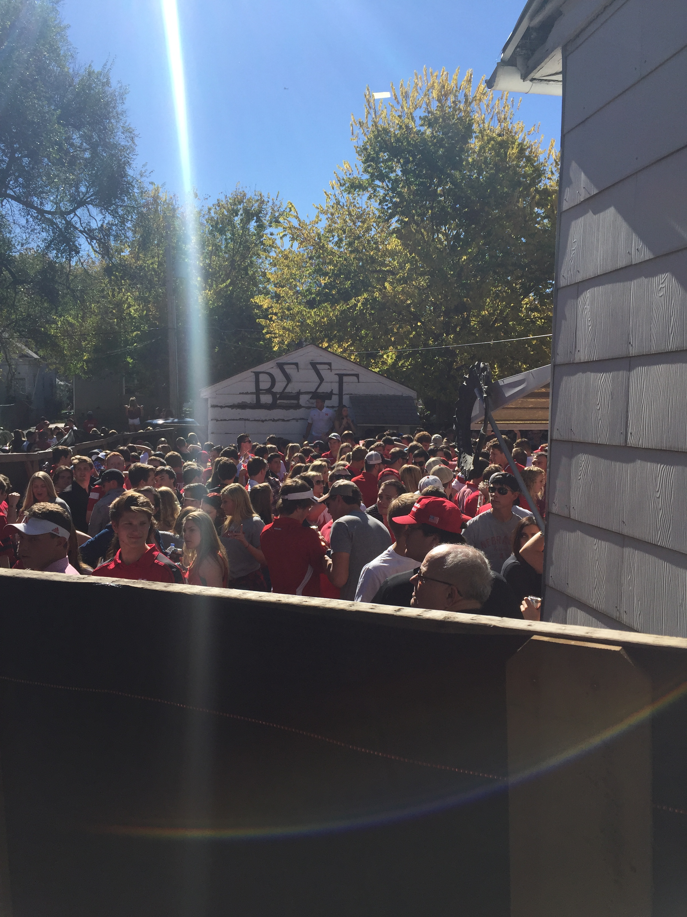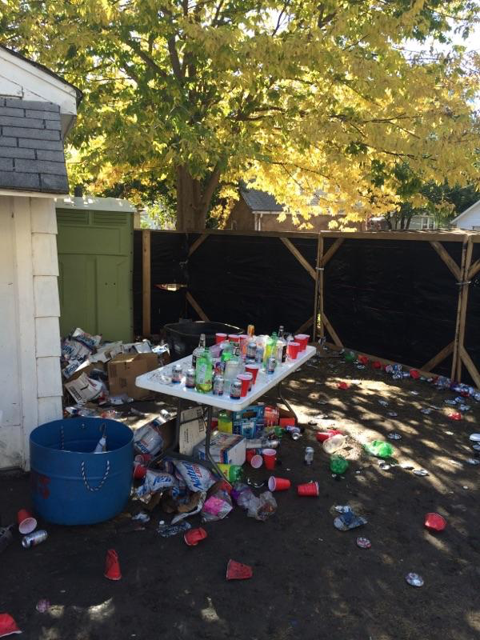
SUMMARY
Any increase in the problems associated with high-risk alcohol use among students is cause for concern. Key findings from this Briefing Report include the following:
- While the University of Nebraska-Lincoln has realized declines in binge drinking among the general student population (62% in 1997 to 38% in 2015), the University Greek community’s binge rate (63% for men and 62% for women) remains higher than the national average of 37%.
- Beginning with the 2002-2003 academic year, the campus experienced a shift from a majority of infrequent and frequent binge drinkers to a significant percentage of incoming students who report either abstaining from alcohol or drinking in low risk ways when they choose to consume alcohol. However, the binge rate of students interested in joining the Greek system exceed 31% - nearly double (15.7%) of their non-Greek peers.
- Since 2013, University student admissions to civil protective custody have increased by 41%. Students admitted with BACs in excess of .20 have increased by 32%.
- The majority of alcohol-related citations issued to Nebraska students are for Minor in Possession/Consumption (76% during the 2015-2016 academic year). Members of the University Greek community are overrepresented in the violation data collected during the 2016 Fall semester.
- The percentage of wild party calls and repeat complaints increase by 12% and 25% respectively during the first five months of the 2016-2017 academic year. Approximately 50% of the post event investigations identified Greek community involvement.
The Campus-Community Task Force is not without a roadmap. Almost 20 years ago, a similar group launched a similar initiative with a much broader scope. Using an environmental approach involving education, policy and enforcement, the campus realized a 44% decline in the student high-risk drinking rate and a similar decline in primary and secondary effects.
This report is intended to provide the necessary background information to help identify targets for intervention. A subsequent report will be prepared and distributed describing the evidence-based strategies currently recommended by the National Institute of Alcoholism and Alcohol Abuse for colleges and universities.

References
Glassman TJ, Dodd VJ, Sheu JJ, Rienzo BA, Wagenaar AC (2010) Extreme ritualistic alcohol consumption among college students on game day. Journal of American College Health 58:413-423
Gruenewald PJ, Johnson FW, Light JM, Saltz RF (2003) Drinking to extremes: theoretical and empirical analyses of peak drinking levels among college students. Journal of Studies on Alcohol 64:817-824
Naimi TS, Nelson DE, Brewer RD (2010) The intensity of binge alcohol consumption among U.S. adults. American Journal of Preventative Medicine 38:201-207
Neuman IM, Shell DF, Major LJ, Workman TA (2006) Use of policy, education, and enforcement to reduce binge drinking among university students: the NU Directions project. The International Journal of Drug Policy 17:339-349
Wechsler H, Nelson TF (2008) What we have learned from the Harvard School of Public Health College Alcohol Study: focusing attention on college student alcohol consumption and the environmental conditions that promote it. Journal of Studies on Alcohol and Drugs 69(4):481-490
White AM (2017) Commentary on Patrick and colleagues: high intensity drinking among young adults in the United States: prevalence, frequency, and developmental change. Alcoholism: Clinical and Experimental Research 41(2):270-274

